Docker compose lab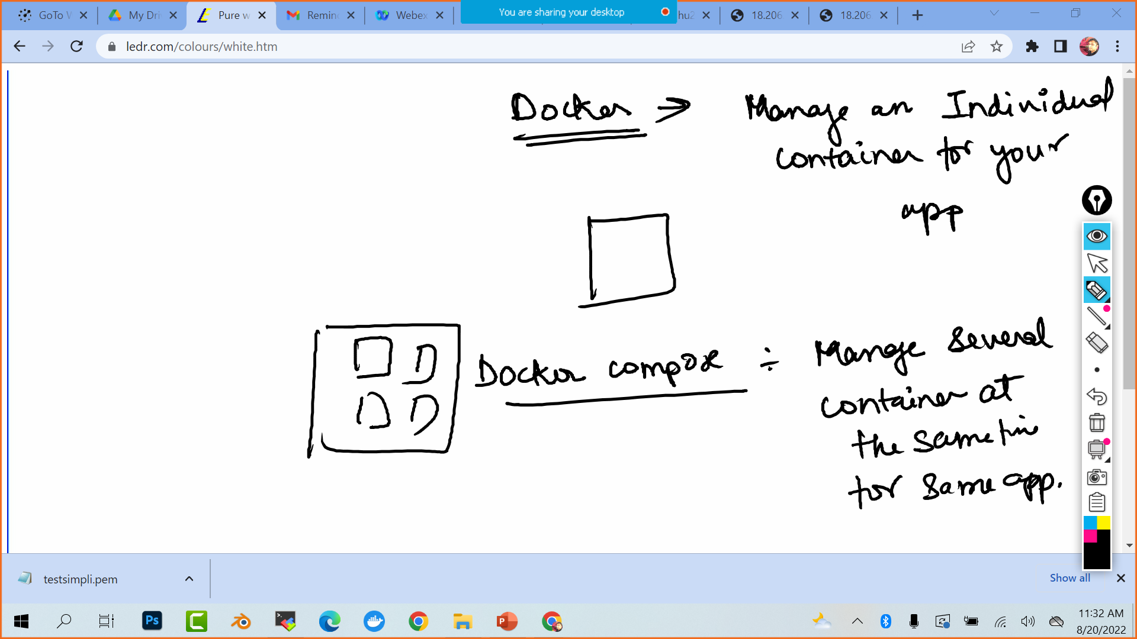

Fork <https://github.com/akshu20791/docker-compose-lab>

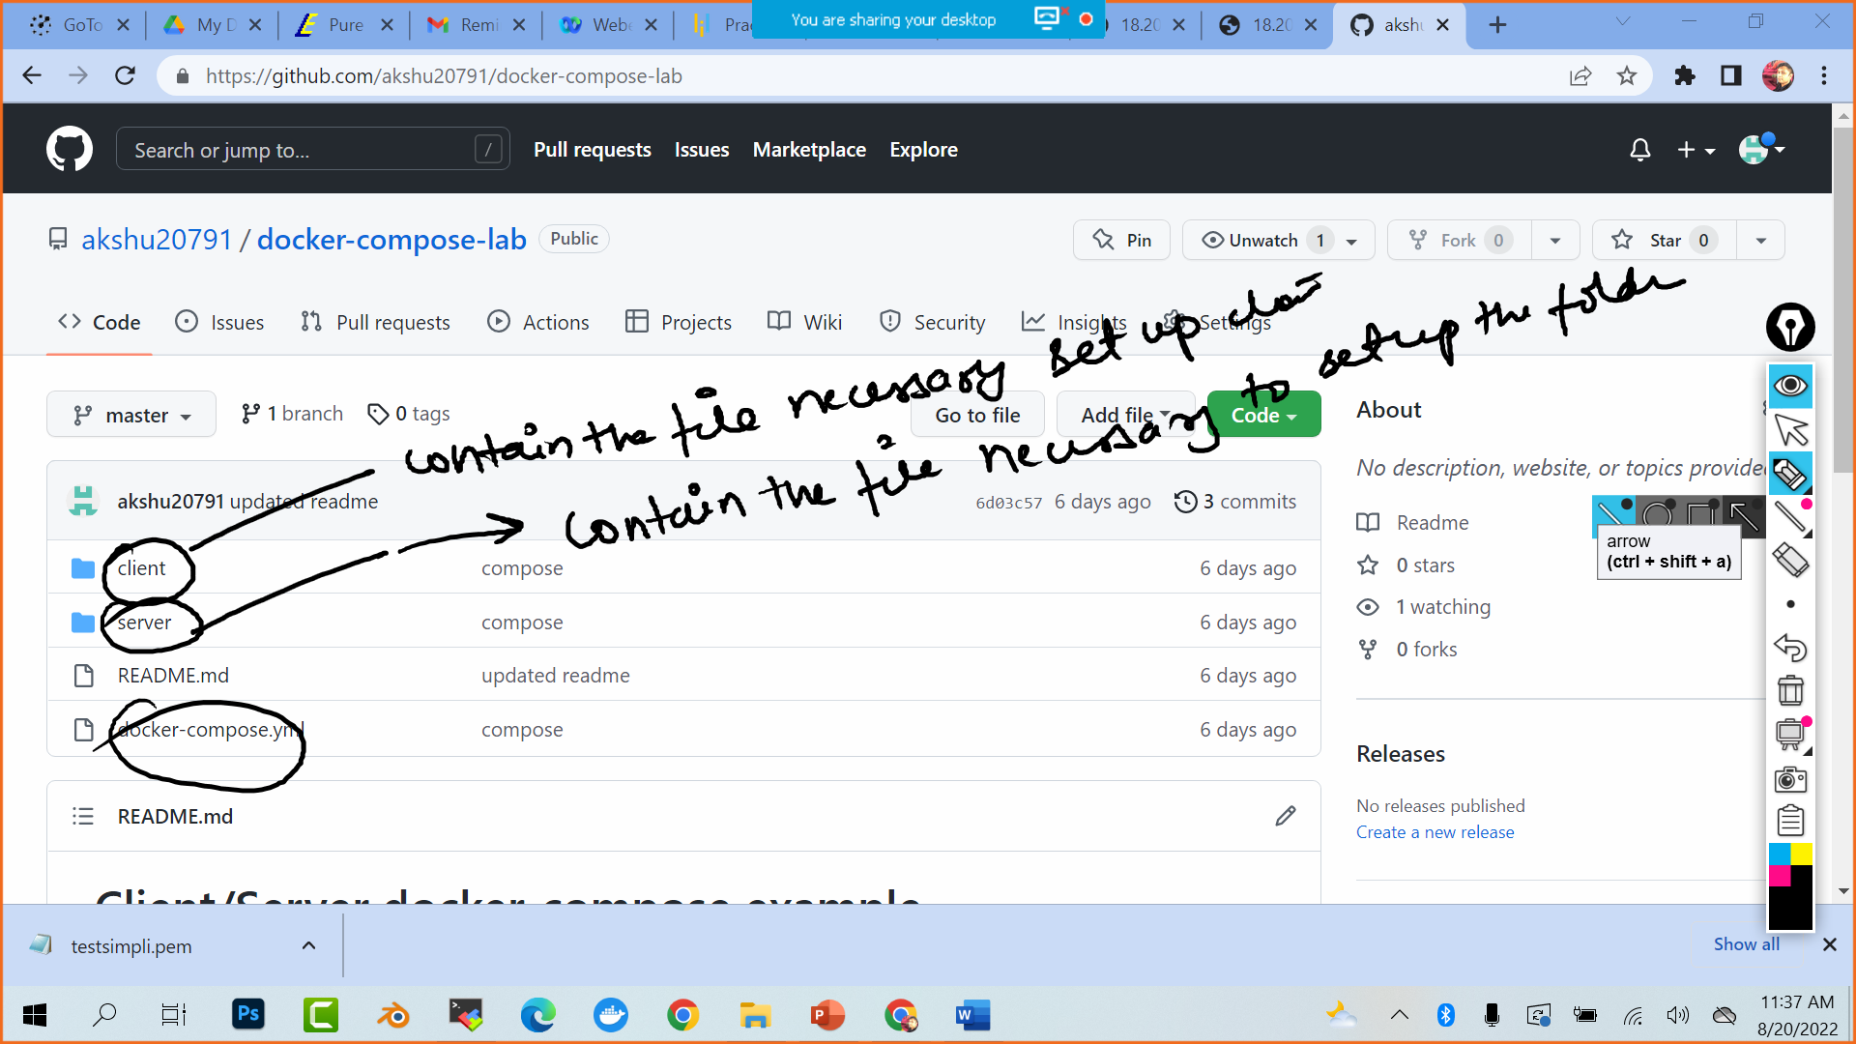

Launch ubuntu machine in aws

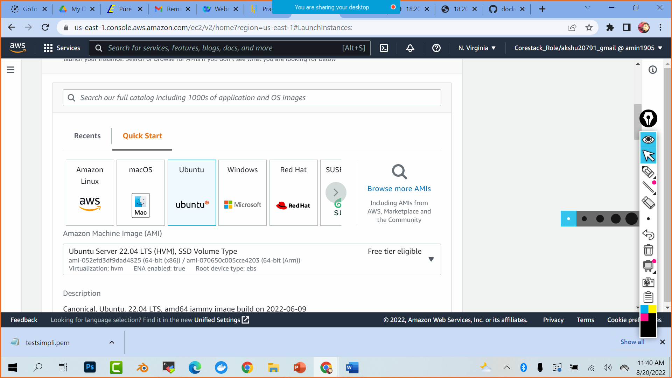

sudo su

spt-get update -y

docker

apt install docker.io

systemctl start docker

git clone <https://github.com/akshu20791/docker-compose-lab.git>

ls

cd docker-compose-lab

apt install docker-compose

docker-compose build

docker-compose up

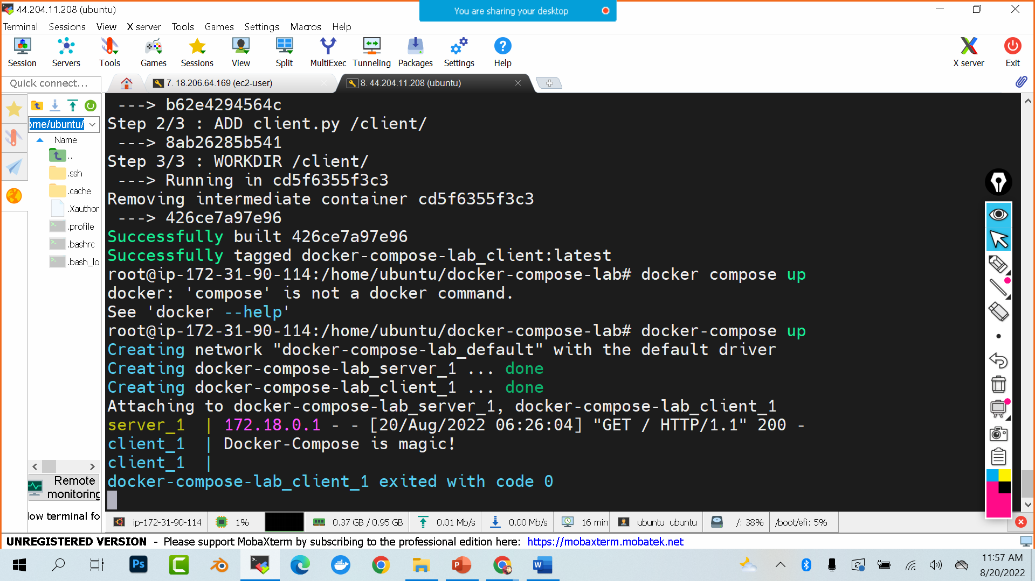

If you see Docker-compose is magic it means you have done lab successfully